**Disabled Veteran Home Modification Act**

Model Legislation Guide

*For the 2026 Legislative Year*

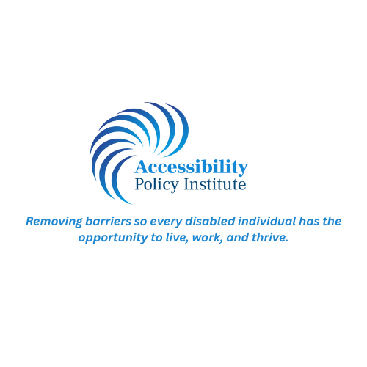

**INTRODUCTION**

After serving our country, veterans who return home with life-altering injuries–some with permanent disabilities–face a whole new set of challenges. Veterans with mobility disabilities may have to significantly modify a home to accommodate their new reality.

According to the CDC, 12.2% of the American population has a mobility impairment, which is defined as “serious difficulty walking or climbing stairs.” Most houses have one or more steps to access the property and contain additional interior barriers, such as narrow doorways or a bathroom too small to accommodate mobility aids like a wheelchair or walker. With only 5% of the American housing stock considered “accessible” and only 1% being accessible to individuals in wheelchairs, finding suitable housing for a disabled veteran can be extremely difficult.

More often than not, a disabled individual has to retrofit an existing property in order to have access. Whether it be building a ramp to allow access up the outer steps or moving a wall to make the bathroom usable, the fees associated with the required construction permits can be significant. In some cases, these permits cost hundreds of dollars for a modification that is essential to make the home usable, further creating a significant financial barrier to making the home functional for one’s needs. Such barriers can block a veteran’s ability to reintegrate into their community and civilian life.

It should not be this way.

The Disabled Veteran Home Modification Act, based on Illinois’s new law enacted in 2025, bars the imposition of building permit fees by a local unit of government associated with home modifications that are specifically required to accommodate a veteran’s disability. It is a small way that we can thank them for what they have given up for us and help ensure that a disabled veteran can access and utilize their home.

For more information or drafting assistance, please contact us at 847.238.2102 or Info@AccessibilityPolicyInstitute.org.

**Dan McConchie**  
 Chief Executive Officer  
 Accessibility Policy Institute

Note: While this model bill is tailored specifically to disabled veterans due to their unique place in society, a state or locality may wish to expand the bill to cover any disabled individual.

**Disabled Veteran Home Modification Act**

**HOUSE/SENATE BILL No. _______________**

**By Representatives/Senators _______________**

**Section 1. Title.**

This Act may be cited as the “*[Insert name of State/Locality*] Disabled Veteran Home Modification Act”.

**Section 2. Legislative Findings and Purposes.**

(a) The [*Legislature or name of local unit of government*] of [*Insert name of State/Locality*] finds that:

1. Disabled veterans are being charged permit fees for home modifications made to accommodate a disability.
2. Permit fees cost hundreds of dollars, adding a financial burden for disabled veterans looking to make their homes more accessible.

(b) Based on the findings in subsection (a), the [*Legislature/local unit of government*]’s purposes in promulgating this Act are to further the important and compelling state interests of:

1. Providing that a veteran with a disability, or the veteran's caregiver, shall not be charged any building permit fee for improvements to the residence of the veteran with a disability, if the improvements are required to accommodate a disability.
2. Ensuring that disabled veterans can comfortably live in their homes.
3. Ensuring that disabled veterans are not burdened by financial barriers when modifying their homes to accommodate a disability.
4. Reintegrating veterans into their communities and a civilian lifestyle.

**Section 3. Definitions.**

For the purposes of this Act only:

(a) “**Veteran”** means someone who has served in the Armed Forces of the United States, National Guard, or the reserves of the Armed Forces of the United States.

(b) **“Disability”** means an individual[1]:

1. that has a physical or mental impairment that [substantially limits](https://www.law.cornell.edu/definitions/uscode.php?width=840&height=800&iframe=true&def_id=42-USC-1904506147-717106290&term_occur=999&term_src=title:42:chapter:126:section:12102) one or more major life activities of such individual;
2. that has a record of such an impairment; or
3. that is being regarded as having such an impairment.

**Section 4. Text of Act[2]**

(a) A veteran with a disability or the veteran's caregiver shall not be charged any building permit fee for improvements to the residence of the veteran with a disability if the

improvements are required to accommodate a disability of the veteran. Nothing in this subsection changes the obligation of any person to submit to the [*Insert relevant governmental entity: county, village, township, etc.]* applications, forms, or other paperwork to obtain a building permit. A veteran or caregiver must provide proof of veteran status and attest to the fact that the improvements to the residence are required to accommodate the veteran's disability. Proof of veteran status is to be construed liberally.

(b) What constitutes proof of veteran status shall be determined by the [*Insert relevant governmental entity: county, village, township, etc.]*.

[(c) A home rule [*Insert relevant governmental entity: county, village, township, etc.*] may not regulate building permit fees in a manner inconsistent with this Section.][3]

**Section 7. Effective Date.**

This Act takes effect on [*Insert date*].

For further information regarding this or other Accessibility Policy Institute guides, please contact:

**Accessibility Policy Institute**

795 Ela Road, Suite 210

Lake Zurich, Illinois 60047

847.238.2102 | Info@AccessibilityPolicyInstitute.org  
AccessibilityPolicyInstitute.org

This policy guide may be copied and distributed freely as long as the content remains unchanged and Accessibility Policy Institute is referenced as the creator and owner of this content.

1. Your State/Locality may have a well established definition of disability. If so, it may reference its own definition. If your State/Locality does not have a definition of disability, the ADA definition listed in Section 3(b) is acceptable.
2. For states: Depending on the setup of your state’s code, you may need to draft multiple separate sections using this template, each addressing the different levels of government that issue building permits (i.e., counties, municipalities, townships, etc.).
3. This section needs to only be included only if the State is a home rule state.